Setup and Profiling Guide

1. **Configure DAQ with Physical or Simulated Chassis**
2. **With Physical Chassis**
3. Plug the Chassis into USB and Power
4. Open Measurement and Automation explorer
5. Rename the DAQ and modules so that they have the following names

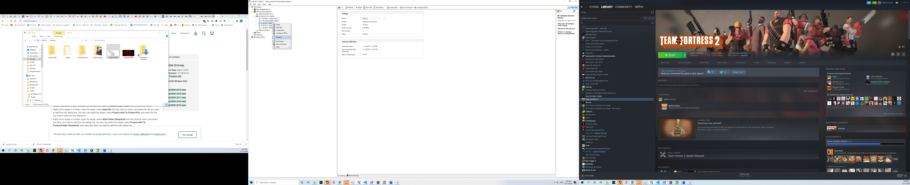

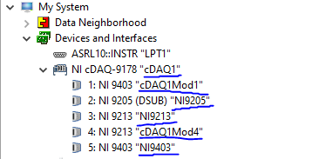

1. **With Simulated Chassis**
2. In Measurement and Automation Explorer create a new device

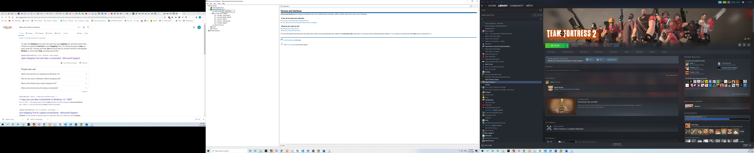

1. Choose “Simulated NI-DAQmx Device or Modular Instruments”

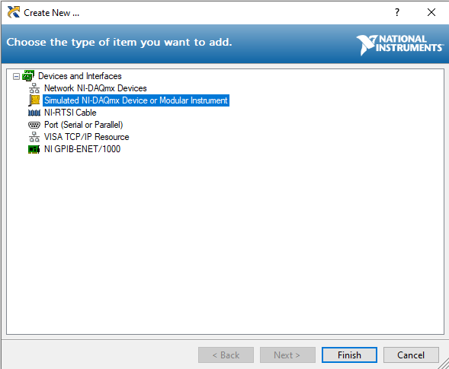

1. Choose CompactDAQ Chassis -> NI cDaq-9178

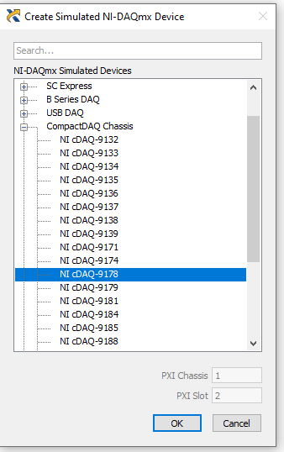

1. Configure the newly created Chassis

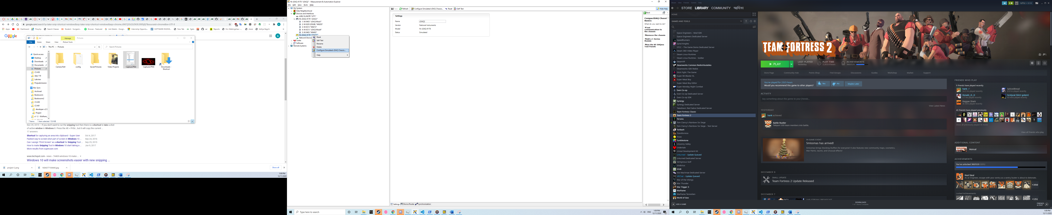

1. Set it up like this

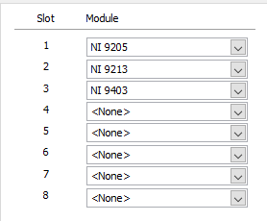

1. Rename the DAQ and modules in the following way

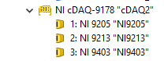

1. **Install Python 3.6 (32-bit)**
2. Download from <https://www.python.org/ftp/python/3.6.0/python-3.6.0.exe> for windows. If you are on another system, make sure to get the 32-bit version.
3. Install and make sure to check “Add to Path”
4. **Labview**
5. Open DAC_V1.vi in LabView (32-bit)
6. If it asks to find a .vi dependency, locate the similarly named dependency in the repo
7. If there were invalid identifier errors, make sure you completed the DAQ setup correctly
8. If there is a python interpreter error, make sure LabVIEW and your python installation are both 32-bit
9. Press CTRL-E to inspect the code and change this to the path for your copy pyign v3 (we still need to get this)

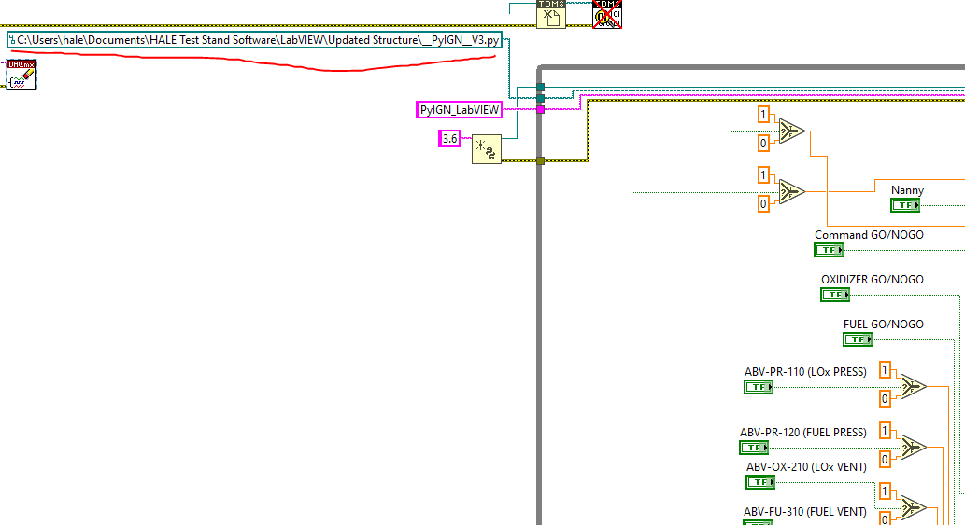

1. Switch to the front-panel view and press run

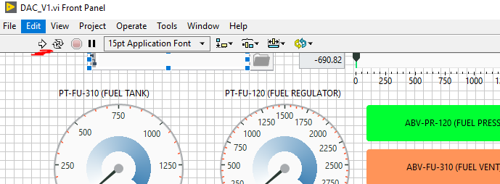

v.

Verify that the numbers on the front panel are changing and that this indicator is reporting the reporting rate of the panel. (Until we get pyign, the python rate will not report)

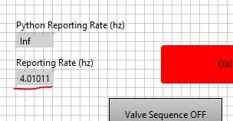

1. **Profiling and Optimization**
2. **Using the Performance and Memory Profiler**
3. In the top bar, click Tools->Profile->Performance and Memory

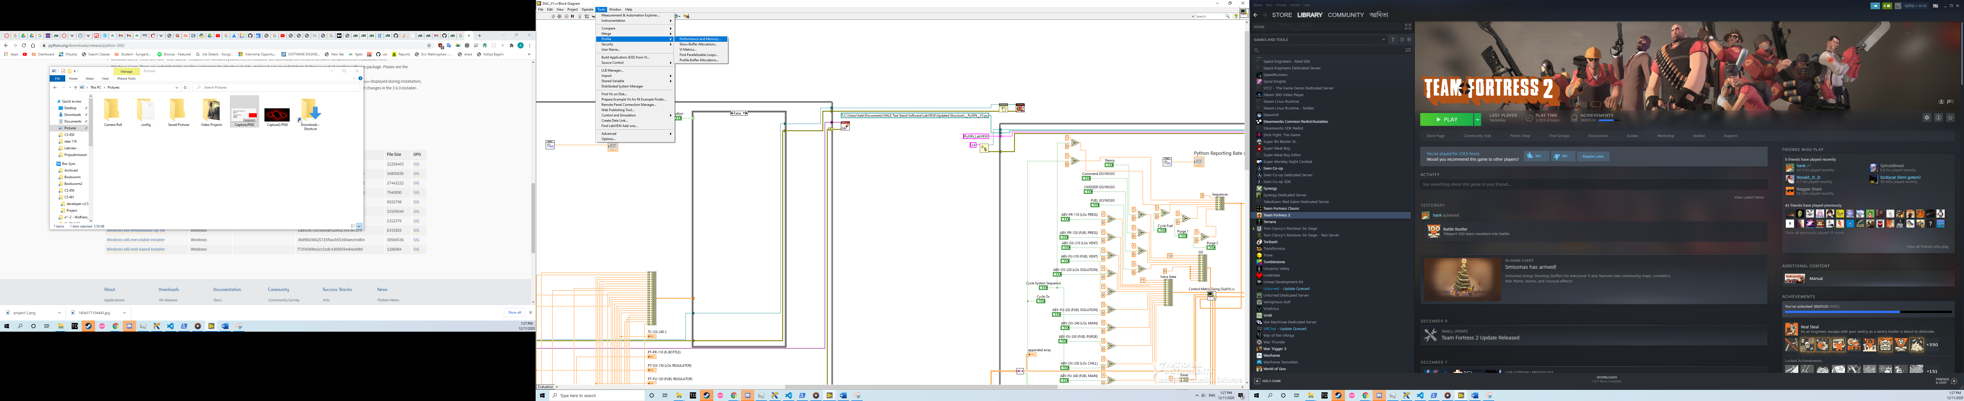

1. Start the program, then press “Start”

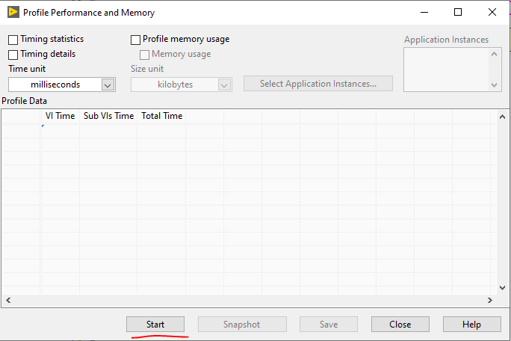

1. Let the program run for 10 seconds, and while it is still running, press “Stop”. The sub-vi’s performance metrics will then be shown.
2. **Parallelize Loops**
3. In the top bar, click Tools->Profile->Performance and Memory to see a list of all parallelizable loops marked with a green check in the result column. 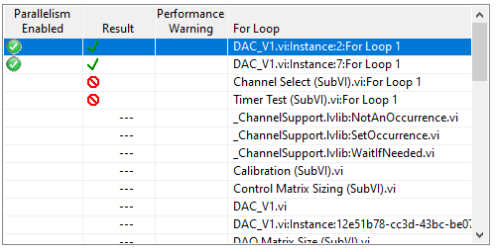
4. Right click on a loop to open its code and then right click again and select “Configure Iteration Parallelism”.

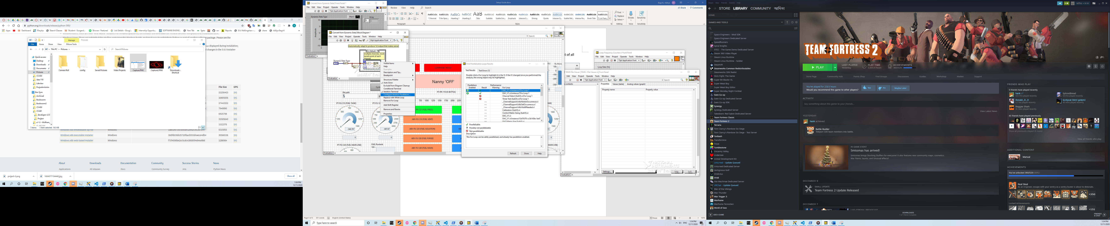

1. Check “Enable loop iteration parallelism”, specify the number of threads and press ok to parallelize the loop.

